**A New Feeling in Contemporary Painting – An investigation of the Contemporary Painters Actions**

**Joshua Paul Mallia**

**CONTENTS PAGE**

**INTRODUCTION** 3 **CHAPTER 1**

1.1 BECOMING FAMILIAR WITH MODERNISM AND POST-MODERNISM 5 1.2 ON THE IMPORTANCE OF THE PAINTERS AWARENESS 8

OF EPOCHAL SHIFTS

**CHAPTER 2**

2.1 METAMODERNISM - TENSION VIA OSCILLATION  9

2.2 CULTURAL CREOLISATION OF THE ALTERMODERN 14

**CHAPTER 3**

3.1 INTERIORITY 19

3.2 AUTHENTICITY 22

3.3 THE INEFFABLE 26

**CONCLUSION** 31

LIST OF REFERENCES 34

LIST OF IMAGES 38

APPENDIX 50

**INTRODUCTION**

In this dissertation, I aim to present a critical investigation of the primary tenets that characterise how contemporary painters are working today by analysing relevant recent writings and artworks. As well as this, I aim to explain how shifts in cultural sensibilities might influence how one can come to comprehend Contemporary Painting. I intend to interpret and explore my findings on the chosen topic, retrieved from various relevant books, articles, essays, lectures, and documentaries produced by distinguished thinkers and critics. I will also explore my personal engagement with the works of selected contemporary painters.

The ensuing investigation will present a critical enquiry into the work of selected cultural theorists. These writers have contributed their observations regarding a significant shift in cultural suppositions and perspectives followingPost-Modernism. It is my aim, within this piece of writing, to demonstrate the ideas of others clearly, while always directing thoughts back to the location of contemporary Painting. Primarily, I aim to show personally synthesised views in response to chosen academics’ and scholars’ ideas.

One might wonder, as I certainly do, what is the use in undergoing an investigation of this new, shall we say, era? Specifically, as a painter, what benefit will this garner regarding a personal, creative practice? Even if the Artist is highly aware of the current milieu’s defining characteristics, should the Artist’s thinking or actions change? My initial, immediate thought tells me, ‘no.’ An artist, or any individual for that matter, should not work to serve and perpetuate the ideals of any grand narrative or prevailing structure of thought. One should be sceptical of anything of this nature!

Nonetheless, the questions mentioned above are not the type to be so quickly answered and dismissed. It seems then that these are the problems that I feel compelled to resolve as someone working within this new milieu. At the start of this intellectual struggle, I was aware that the root of my innate scepticism, meaning my naturally distrustful attitude to new notions or problems, is demonstrative of why the questions above are as important as they are challenging. My cynicism, my suspicious and somewhat dismissive response to the value of prevalent cultural shifts, is *not* entirely my own. This scepticism, it seems, is symptomatic of the time that has served as the backdrop to my entire life so far, and that is the time of Post-Modernism.

In this case, Chapter 1 seeks to unpick what drives my innate scepticism by identifying and exploring the comprising tenets of past eras.

Chapter 2 comprehends and responds to the cultural theories of Metamodernism and Altermodernism, two significant interpretations of the new epoch’s definitive happenings.

Chapter 3 investigates the importance of the contemporary Painter’s interiority and authenticity and explores the Artist’s apprehension of the ineffable through a re-emergence of Romanticism in Painting.

Throughout the exploration, I intend to relate various ideas to one another continually.

**CHAPTER 1**

**1.1 IDENTIFYING MODERNISM AND POST-MODERNISM**

Suppose one wishes to understand the current landscape of Painting. In that case, it is essential to first familiarise oneself with the existing time-spaces predecessor, the age of Post-Modernism. Just as the principles of Post-Modernism manifested as a response to the facets of Modernism, characteristics of the milieu we find ourselves in have come to fruition in response to Post-Modern ways of thinking.

Sometime around the 1960s, there emerged a shift in collective western cultural perception. This change manifested by way of a reaction to the until then championed mode of thinking, Modernism. Itself emerging toward the end of the nineteenth century, Modernism was birthed out of hope. Modernist artists strove to produce sincerely authentic artifacts of complete newness. They aimed to innovate and create Art of a sort that had never existed before, intending to generate a newly ideal future. Modernists sought to think objectively, with rationality, and reduce ideas to their most straightforward and fundamental forms. Many Modern painters sought to focus entirely on their work’s formal aspects rather than potentially perceivable narratives or concepts. (Tate, n.d)

Modernism espoused hope and progression. It championed new grand narratives and ideologies. Doing away with any conservatism or traditionalism, Modernists strove earnestly with vigour into a new dawn, where, over the horizon, was the future all wanted. Unfortunately for the Modernists, over the horizon was the twentieth century. This period is now, in hindsight, most easily characterised by complete despair. Despite Modernism’s ambition and idealism, the twentieth century consisted of two World Wars’ utter turmoil, the atrocities of Mao’s Communist China, and the Soviet Union’s barbarities as well as multiple civil wars and genocides. (IWM, n.d) (White, 2004)

It seems obvious now that Modernism, a movement founded on the ideals of progression and utopianism, would fall out of the favour of most peoples who had to persevere through incessant hardships.

Then arose Post-Modernism, the new, global lens of perception that sought to resolve Modernism’s issues and replace outmoded thought. Post-Modernism insisted on scepticism and distrust of reason as a reaction to Modernism’s ambition and grand aims. Post-Modern thinkers set out to dismantle any grand narratives or structures of thought, breaking down rules and dispensing with authority. Post-Modern relativism dispelled any belief in the idea of universal, objective truths and instead proposed that all concepts are subjective and relative to individuals and their environments.

Post-Modern artists embraced a new era, one in which *anything* was permissible as Art, where anything could be contextualised as a work of Art if an artist chose to do so. American Art critic Arthur Danto highlights this by referencing American Artist Andy Warhol’s work (Fig. 1, 1964) in his essay “The Artworld” for The Journal of Philosophy;

What in the end makes the difference between a Brillo box and a work of Art consisting of a Brillo box is a certain **theory** of Art. It is theory that takes it up into the world of Art, and keeps it from collapsing into the real object which it is … Of course, without the theory, one is unlikely to see it as Art.

(1964, p.581)

With the dismissal of old rules and the widely embraced idea that anything could be Art if contextualised as such, an emphasis on concept over form emerged. Post-Modern artists used irony as a weapon of sorts, which allowed them to reference historical artworks and other cultural artifacts in a comical but often cynical manner. As well as references to the work of others, Post-Modern Art often employed self-referentiality and displayed self-awareness. This Post-Modern tact seemed to work as a defence against any judgement, in turn stating and preserving coolness or in-ness; One cannot consider artwork to be lacking if not only any criteria of value or reason is no longer in place, but too said artwork displays awareness of its own nature, as well as a nonchalance about it.

 For those born into the time of Post-Modernism, like me, this has been the default mode of operation. Sarcasm, irony, and the mocking of sincerity were always the standards. Though speaking solely for myself, I feel a deep yearning for something else, something new perhaps. Lack of narrative and value structures has left one aimless and tired. Once jovial and satirical, Post-Modern irony seems to have turned to contempt, a nihilism of sorts. This contempt is for the very thing it was born of, that being Post-Modernism.

It is now becoming clear that these feelings are shared, and something new is in the process of surfacing. I aim to shed light on what this sense of a new mode of thinking might be through my research investigations in this dissertation. I aim to investigate the contemporary Painter’s current actions and reactions to previous epochal doctrine and determine how those actions produce the new period’s primary tenets.

**1.2 ON THE IMPORTANCE OF THE PAINTER’S AWARENESS OF EPOCHAL SHIFTS**

Let us briefly return to the questions posed earlier - What is the use in undergoing an investigation of this new era? As a painter, what benefit will this garner regarding a personal, creative practice? Even if the Artist is highly aware of the current milieu’s defining characteristics, should the Artist’s thinking or actions change?

After gaining a better understanding of recent shifts in cultural and artistic perception, I am slightly more inclined to say; the Artist *should* align the actions and processes of their practice with their intellectual response to epochal shifts, to some extent at least. Although it seems we move naturally and collectively through changes in culture, and we are bound to be the products of our time, gaining a concentrated awareness of our environment, our time, and our culture can benefit our individual lives and practices. This awareness grounds one within their vastly spanning network. One becomes aware of their role as part of a tremendously expansive system. It also provides the Artist with information to respond to; this can be of great use and benefit! Artists might feel relieved to learn about the overwhelming thought structure and might work to champion this structure’s values through their work. Some could challenge notions and adapt their practice to propagate ideas contradictory to the ruling school of thought. Different artists might not care at all and continue business as usual! Others will possibly observe new, previously unnoticed cultural happenings and bring them to attention through their work. Either way, artists are becoming aware of the tenets of the intellectual realm they operate within and subsequently contribute to their domain’s principles. It is becoming clear to me that this is crucial to the maintaining and replenishing of vitality and momentum in Art and culture.

If Post-Modernism is dead, what then rises from its ashes? The next chapters will review central theoretical perspectives that influence my activity as a painter and seem representative of the present milieu.

**CHAPTER 2**

**2.1 METAMODERNISM - TENSION VIA OSCILLATION**

A prevailing idea regarding the new age contemporary culture is embracing is one penned by philosophical theorists Timotheus Vermeulen and Robin van den Akker. That premise is Metamodernism.

To briefly summarise, the writers present the idea that Metamodernism is fundamentally characterised by a tension generated via the oscillation between Post-Modern and Modernist principles. Cynicism, irony and the rejection of narrative and supposed universal truths oscillate with sincerity, idealism, and the desire for personal and societal progression.

One should be careful not to think of this oscillation as a balance however; rather, it is a pendulum swinging between 2, 3, 5, 10, innumerable poles. Each time the metamodern enthusiasm swings toward fanaticism, gravity pulls it back toward irony; the moment its irony sways toward apathy, gravity pulls it back toward enthusiasm. (van den Akker & Vermeulen, 2010, p.u.)

The writers establish a fascinating idea and an essential distinction between the concepts of balance and oscillation. To suggest that juxtaposing Modern and Post-Modern values *balance* within the Metamodern paradigm indicates that these opposing, reactionary values share the same conceptual weight when observed in, or applied to, any given moment or scenario. It is significant then that the authors clarify that this is not what they recognise. Instead, what they see is *oscillation*. Conflicting principles battle it out for centre stage, but with mediation. The battling is reconciled by an overruling force of nature (the authors use the word gravity), which produces *tension*.

Artists now feel free to present sincere, personal ideas without the fear of their works being deemed naïve and simplistic by the cynical eye of Post-Modern irony and relativism. Simultaneously though, artists also feel equally free to engage with irony and complex concepts. Concerns that Modernist modes of reductionism might degrade their works are reconciled. This freedom to engage in opposing ideas simultaneously without them immediately cancelling each other out produces the Metamodern, oscillatory tension. This tension should not be perceived as inherently negative (nor positive) but instead as a natural symptom of our time. If one were to consider this more holistically, this tension might be regarded as a natural manifestation of life. Let us briefly pay more attention to this thought for clarity’s sake.

Vermeulen and van den Akker wrote their original essay “Notes on metamodernism” not as pontification. The text is not a prescriptive guide to how Art and culture should be made or viewed; it is not a set of dogmatic rules according to which we should all proceed with our business. Instead, the authors provide observations, referring to what they present as a “structure of a feeling” (van den Akker & Vermeulen, 2010, p.u). To reiterate, the writers describe this structure of a feeling as one fundamentally characterised by an oscillation between the oppositional values of Post-Modernism and Modernism, specifically. One could argue that the current tension observed (within the world of contemporary Painting specifically) is not one produced *only* by the juxtaposing of Modern and Post-Modern ideas but also the oscillatory nature of *all* things.

I must clarify that the oscillation Vermeulen and van den Akker recognise as indicative of Metamodernism is strictly between Modern and Post-Modern values. Instead, I am proposing that oscillation boundaries are not set only around Modern and Post-Modern values within the realm of contemporary Painting. Contemporary painters operate in a boundless territory, full of infinite properties that oscillate with their opposites, producing tension.

Contrasts generate reality. One can only recognise the existence of any single thing by simultaneously acknowledging its opposite. Any painter worth their salt is as aware of this as anyone else. Like a Taoist sage, today’s Painter is ever mindful and accepting of the Yin and the Yang of existence, for their actions facilitate oscillation. The Painter sets the stage for oppositional tension to occur on every surface they create on. Every contemporary Painter’s daily toil consists of repeatedly making decisions regarding how best to deal with opposing elements. For instance, the Painter must consider how best to treat tone, possibly employing the darkest darks and the lightest lights. Perhaps a vast spectrum of middle ground existing between those values most highly contrasting. How is colour to be handled in correspondence with the Artist’s intentions? The Artist might ponder how highly chromatic pigments might interact with neutral greys and browns and to which extremity of the range they push the Painting to. They might wonder how complementary colours, if employed, should or should not cooperate. Today’s Painter is free to traverse a range of subject matter, potentially choosing to render depictions of representational imagery with varying degrees of visual realism. On the other hand, they might decide to do away with figuration and generate entirely abstract paintings. The contemporary Painter operates within a liminal field, swaying from one possibility to its parallel, perfectly content to navigate the territory between order and chaos, between knowing and unknowingness.

German painter Ruprecht von Kauffman thrives within this in-between space. The 2019 painting ‘No Mans Land’ (Fig. 2) perfectly demonstrates Kauffman’s masterful handling of painterly inverses. The image is a strange one, rich with tension, and makes for an uneasy viewing experience. Loose strokes of blue-violet oil paint, varying in tonal value and chromatic neutrality, make space for imagery to inhabit. On the composition’s right side is a stern figure, dressed in military garb and armed with an assault rifle, sitting broodingly on a humble wooden chair.

The figure’s uniform’s rendering is slick; the Artist places light and shadow with great deliberation, generating the natural forms of creased clothing. However, in contrast to visibly sophisticated, realistic rendering, the figure’s face is entirely shadowed and painted flatly, singular in colour and tone. The strange lack of visible facial features adds an unnerving ambiguity to the character and the Painting as a whole. Kauffmann increases alternation between levels of naturalism by depicting the figure’s boots with drawn lines only, juxtaposing visual depth with a flat, sketched quality. Swaths of scumbled grey paint around the model make for the appearance of a smoky atmosphere.

Above the figure, blobs of warm, golden, yellow-orange paint act as subtle lights, contrasting with the dark, *complementary*, cool violet hue that influences most of the Painting. To the left of the image is a dog, large and powerful in physique, facing the seated soldier’s *opposite* direction. Apart from its haunch, illuminated by the golden light above, cold shadow obscures the dog, heightening mystery and tension. The Artist visually severs the dog’s rear legs and does not paint them in, disrupting the viewers’ apprehension of the image’s logic. Kauffmann carves lines into the Painting’s linoleum surface, creating a minimal illustration of running legs, which lines’ meander and dissipate at the waist, disrupting logic further. At the centre of the Painting, a beautiful *counterpoint* settles the image’s overall shadowy, absurd, and nervous mood. As the image recedes from the viewer, at the very back of the scene is a window, from which pours streams of white light, and through the window are two figures, sharing an impassioned physical embrace. Through Kauffmann’s skillful use of painterly polarities and subsequent compelling tension, the viewer experiences a painting loaded with narrative potential, aesthetic discovery, and a profoundly emotional atmosphere.

Painters lean into modes of polarity and oscillation in various manners, utilising idiosyncrasies and quirks of their unique visual languages. For example, American Painter Lois Dodd generates oscillation through her modest yet elegant paintings of windows (Fig. 3, 2014). Compositional cropping distorts the viewer’s apprehension of the image; the distinction between the interior and exterior is not necessarily obvious. Vibrantly warm and cool colours coalesce and simultaneously counterattack on the surface, describing forms. The tension created via these particular ways of oscillation elevates the beauty and mystery of the Artist’s quotidian scenes.

The works of British Painter Hurvin Anderson evoke another sort of tension (Fig. 4, 2010). Oscillation occurs via the dissolution of recognisable forms. Representations of exotic plants become abstract plains of vivacious green paints and continue to go back and forth in the viewer’s minds-eye. Geometric shapes are often employed to bar the viewer from entering the visual space and disrupt the distinction between positive and negative space. The tension produced in Anderson’s work through his linguistic particularities is subsequently opulent and enchanting.

A recognisable commonality of painting practice within the current milieu is the production of oscillation, but how this oscillation occurs is through each individual Painter’s perspective and syntactic particularities. The Contemporary Painter is not only confident in simultaneously employing oppositional tactics of Modernism and Post-Modernism. The Painter is also willing to explore a limitless space, rich with painterly possibilities, identifying and utilising oscillatory relationships in keeping with their syntax and practical methodologies. Subsequently, the Painter continually produces new tensions, profoundly contributing to the new feeling in Contemporary Painting.

**2.2 - CULTURAL CREOLISATION OF THE ALTERMODERN**

It is useful to consider and investigate another contemporary cultural theory, Altermodernism, a concept spawned and suggested by Nicolas Bourriaud.

In the Altermodernism manifesto (2009), Bourriaud defines the main characteristics of contemporary Art and culture, which he proposes make up our current cultural environment, that of Altermodernism. It is interesting, and I would suggest essential to consider Bourriaud’s perspective in relation to Metamodernism.

Primarily, Bourriaud suggests that a new, globalised hyperconnected culture, a creolisation of previously internationally varying values, has replaced multiculturalism (in the sense that individuals, or collective groups, diversify their identities by appropriating components of a multiplicity of cultures).

Many signs suggest that the historical period defined by post-modernism is coming to an end: multiculturalism and the discourse of identity is being overtaken by a planetary movement of creolization. (Bourriaud, 2009. p.u.)

Instant global communication and increased international travel has resulted in a new, internationally homogenised lens of perception, Bourriaud suggests. This mode of awareness is one through which artists can perceive their individual experiences and expressions as not only “played out against a more enormous backdrop than ever before” (Bourriaud, 2009, p.u), but equally as being an integral part of a vast, globally interconnected realm.

Bourriaud suggests that contemporary artists create work to communicate their traversing of our newly culturally interwoven landscape. No longer are any singularly defined forms of artistic expressions or movements bound to the understanding only of peoples from a particular geographical location or cultural instant; today’s Art instead can speak in a global, timeless language. According to this mode of thinking, then, Bourriaud claims the Artist’s role is similar to that of the explorer. The Artist locates newfound treasures to adopt and subsequently reinterpret to fit their already existing collection of goods. Today’s Artist naturally uses their ability to, with the power of the internet and modern communicational devices (smartphones, computers), easily view and engage with artifacts, imagery and ideas which were previously much further than a few taps away. The Artist may also trek across time, taking advantage of their ability to reconjure history and project into *a* future. The resulting works of the instantaneously well-travelled Artist are depictive of their makers journeying: “The form of the work expresses a course, a wandering, rather than a fixed space-time”, Bourriaud writes (2009, p.u).

After investigating the ideas encompassed by Altermodernism, one can see how they contribute to oscillatory tensions in contemporary Painting. With enhanced international interactions, the Painter can freely explore the artistic traditions and activities of practically any country and culture. The Artist now has access to all sorts of artifacts from any place and any moment in history. Consequently, philosophies, traditions, and techniques that may have originated in many different locations and varying points in time might all work to influence the individual Artist. Differing ideas from many times and places coalesce in the Painter’s perspective. Therefore occurs another particular type of oscillation, one between culturally specific signs and signifiers. As well as Metamodern tension, the result of this *cultural oscillation,* for the individual Painter, is a new development in visual language. I would suggest that there exists a particular oscillation between locality and foreignness in the contemporary Painter’s work.

By one’s *locality*, I refer to the Painter’s physical whereabouts and, importantly, the Artist’s lived experiences in said whereabouts. The location-specific cultural undertones of one’s whereabouts effects the Artist’s lived experience and naturally informs their practice. The globalisation Bourriaud speaks of exposes the Painter to the foreign; that which is not well understood but can be of great intrigue. Exposure to new artistic culture prompts the Painter to peer out from their locality (the space with which they are familiar and ingrained) and explore the vast realm of the foreign. If they so choose, the Painter can instantaneously investigate and interpret a plethora of material from around the world. When this newly comprehended information, whether it be in the form of philosophies, techniques, imagery, or traditions, is then appropriated and incorporated into the Painter’s practice, their visual language further develops and reveals oscillatory tension. The fluctuation between the local and the foreign is another example of an oscillation between knowing and unknowing.

For example, Japanese Painter Maki Na Kamura’s 2014 painting ‘LD XXIII’ (Fig. 5) sees tension resulting from many oscillations. Na Kamura has appropriated and adapted imagery from French realist painter Jean-François Millet’s painting ‘The Gleaners’ (Fig. 6, 1857) but presents it very differently from the original. The whole piece fluctuates between representation and abstraction. Na Kamura orchestrates loosely applied, flat strokes of paint to create a vague impression of a landscape. Thin, transparent washes of violet and yellow undulate on the surface.

In contrast, Na Kamura layers deliberate ribbons of opaque colours. Shades of earthy green sit against powdery crimson, both amongst larger shapes of dark earth pigments in various degrees of opacity, abstracting from forms of a natural landscape. The gleaners, borrowed from Millet, occupy the centre of the composition. The Artist renders these figures with a gorgeous simplicity, visually describing them with small, shapely globules of paint, sparing on detail. Na Kamura facilitates oscillation via her painterly syntax. An interplay between layers of transparent and opaque colours, in partnership with an interaction between figuration and abstraction, makes for an openly interpretable visual tension.

I would suggest the Artist’s syntax came to develop by way of a cultural oscillation. Being born in Osaka, Japan, Na Kamura has been naturally entrenched in her locality’s specific culture and Asia’s artistic traditions; This is observable when analysing her work compared to traditional Asian Artworks. For example, in the 1832 woodblock print “The Waterfall at Ono on the Kisokaido Road” by Katsushika Hokusai (Fig. 7), one can see an enchanting landscape indicative of the Asian tradition. Tall trees sprawl up the vertical surface shrouded in meandering clouds on the right, alongside cascading needles of water that guide the eye down the rocky cliff-face on the left. The overwhelming sense of verticality, heightened by the piece’s portrait orientation, disrupts any sense of a flat horizon more typical in the western landscape tradition. This disruption is seen too in the whimsical landscapes of Fa Ruozhen, particularly in the 1684 painting “Cloudy Mountains” (Fig. 8). Any sense of retreating perspective, typical of traditional western landscapes, is removed by the flattening of forms onto a single plane, painted with a single pigment.

Returning then to Na Kamura, one can observe how she dances between Eastern and Western tropes and techniques throughout her practice (Fig. 9, 2010). The Artist employs her familiar, traditionally Asian sensibilities in the flattening and abstracting of forms, which eradicates horizon lines and squashes perspective. But too, living and working in Germany, she embraces and reinterprets elements of the western tradition of Painting, borrowing imagery from western historical practitioners and using traditional western materials in oil paint. This oscillatory action results in personal development in aesthetic language, a visual creole that otherwise would not manifest.

One can see how globalisation offers the Painter the opportunity to utilise historically foreign modes of operation and more local, familiar tactics in an oscillatory fashion definitive of the current epoch. This interplay allows the Artist to extend the boundaries of their lived experience and express this expansion through their Painting.

The following chapter works to further comprehend the extension of the contemporary Painter’s limits of existence in relation to ideas previously investigated.

**CHAPTER 3**

**3.1 INTERIORITY**

Greg Dember, author and editor of the website “whatismetamodern.com”, expands upon Vermeulen and van den Akker’s ideas in his work. In his article, “What Is Metamodernism and Why Does It Matter?” (2020), written for The Side View, Dember often employs the term *interiority* and dubs it vital to his conceptualisation of Metamodernism. He writes, ‘The central motivation of metamodernism is to protect interior, subjective *felt experience* from the ironic distance of *post-modernism*, the scientific reductionism of *modernism*, and the pre-personal inertia of *tradition*’ (2018, p.u).

An individual’s interiority is formed by how one experiences life and perceives the world, not only via logical observation but also via emotion and instinct. One’s interiority is the space within which one *feels* immediate, emotional, visceral responses to the world’s stimuli. This interior, experiential space is what Dember suggests individuals of the current milieu seek to protect against Post-Modern and Modern methods of deconstruction and reduction.

To elaborate, Post-Modern practice often sets out to delegitimise artworks that share any sincere expressions by ironically referencing such artworks, then subvert and conceptually deconstruct any initially conveyed concepts (Shugart, 1999). On the other hand, modernist practice often utilises reductionism. Sophisticated levels of meaning or concept in artworks are intellectually reduced to their most straightforward, most fundamental parts. This method works to simplify and lessen the profundity of complex implications produced through the artwork’s sum. Instead, this thinking suggests that any given artwork’s fundamental contextual underpinnings are reducible to simple, universally understood notions (King, 1996).

It is from these modes of operation that Dember proposes contemporary artists aim to protect their interiority.

Dember’s writing on interiority within metamodernism is inspired by German writer Raoul Eshelman’s work, specifically his 2008 book ‘Performatism, or the end of Post-Modernism’ Eshelman explains the concept of “Performatism”, which he dubs the new mode of creation in the new era after Post-Modernism. The writer observes ’a renewed interest in beauty and the discipline of aesthetics, a new seriousness or lack of manifest irony, a renascence of Painting (as opposed to per­form­ance Art and installations) as well as the imposition of unified authorial intent on the represented world’ (Eshelman, 2008, p.195). Eshelman’s main suggestion is that artists, dissatisfied with Post-Modernism, now create work through which they *perform* their personal, sincere, interior faith in truth, beauty, naivety, and morality (Dember, 2018).

Eshelman documents what he observes to be the ruling mode of performance in all kinds of Art; he refers to this approach as “double framing” (2008, p.3). The writer suggests that contemporary, *performatist* artworks engage the viewer by way of two frames of interpretation, “the *outer frame* (or *work frame*) and the *inner frame* (or *originary* *scene*)” (2008, p.3).  The outer frame is a structure in which exists solutions (although not necessarily based in reality) to problems within the artwork, which the viewer must accept without questioning its fantasticality if they are to engage with the work entirely. In the case of a painting, the very nature of being made of paint on a bounded surface demonstrates the separation of its content from reality, immediately implying a degree of fantasy. Once accepting of this, the viewer enters the outer frame and unironically engages with the emotional, symbolic, and conceptual content performed within the inner frame.

The outer frame’s imaginary quality marks an explicit boundary between the content of the work and the real world. Once this is accepted, the viewer is free to connect to the Artist’s felt experience and the beingness of the components that make up the work, and then relate what they experience to their own inner life (Dember, 2018) (Eshelman, 2008).

;

So, to go along with Eshelman’s and Dember’s suppositions, it seems then that today’s artists feel that they can work in a manner where neither Post-Modern nor Modernist modes of deconstruction are detrimental to the safety of their lived, felt experience. I would suggest that today’s artists believe they can safeguard their interior world via *performing* and sharing aspects of their interiority through their work. One can detect another form of oscillation in this action. The Artist channels the personal experiences associated with their interiority to produce paintings that they then share with a globally connected *exterior.* The Artist continually fluctuates between their interior space (where the content fuelling their practice is intellectually and physically apprehended) and the exterior world (where their work can be comprehended once more by others).

**3.2 AUTHENTICITY**

Like all humans, painters are vastly complex beings, very much capable of shifts in perspective and expansion of knowledge. How an individual instinctively *feels* in response to an idea can also change, even without adherence to any logic, as matters of the visceral sort are often obscure and puzzling. One should be careful when going down this line of thought. Can an artist work in a way that is predicated on the oscillation of oppositional factors yet simultaneously work *authentically*? When considering the idea of change within one’s interiority, one should too consider notions of authenticity.

Authenticity is a fundamental idea within *existentialist* thinking, with many thinkers contributing to the central notions within the overarching philosophy. American philosopher Charles B Guignon succinctly writes, “Authenticity suggests the idea of being true to yourself – of owning up to who you really are” (1998, p.u). Existentialists generally do not believe in the idea of an authentic self in the romantic sense, in a way that would propose that some divine nature emanates through us all individually, providing us with a *predetermined* true self (Guignon, 1998). Instead, most insist that the authentic self generates by way of free will, that individuals must strive to become their authentic selves through choices made in all seriousness. One does this by taking responsibility for and committing wholeheartedly to decisions and not by merely acting in adherence with social expectations, hierarchal doctrine, or concepts of a fixed, essential core. French philosopher Jean-Paul Sartre writes with great power along this line of thought “existence precedes essence” (1945, p.1).

What Sartre is suggesting is that we, as individuals, are born, and we then exist. After becoming aware of our own existence, we are entirely free to discover and cultivate a formulation of what we deem to be our true selves through the course of our independently lived realities. To be authentic is to *act* in accordance with this formulation of the self. To live and act *out* of harmony with the true self is to be inauthentic, and for Sartre, it is to live in ‘bad faith’ (1966).

American psychologist Carl Rogers would suggest that someone living in bad faith with their self is living in a state of *incongruence* (1959). For Rogers, to live in a state of *congruence* is to align the actions of the living, experiential self with one’s conceptualisation of an ideal self.

Alternatively, For Danish philosopher Søren Kierkegaard, we, as individuals, are fusions of opposites. Kierkegaard identifies a particular pair of opposites to be most pertinent to the idea of authenticity; *the infinite and the finite* (1941[1849], p.9). The Finite, for Kierkegaard, is knowingness. It is the realm of the now, the experiential, the immediately apparent. It corresponds to one’s definite existence and beingness in the time and space they occupy in the world.

The Infinite, in contrast, is unknowingness. It is the realm of constantly expanding possibility. It is where countless new ideas exist, wherefrom invention originates, and innumerable potential choices present themselves to the free individual (Academy of Ideas, 2015). Suppose one is unaware of the potentiality of the infinite. In that case, they find themselves trapped in the finite, the seemingly caged domain of their current site and where they cannot conceive of an idea of any alternative situation. Although, if one is in denial of the finite, they become ungrounded from tangible reality and become lost in the infinite. They are then continually experimenting with various ways of perceiving life and acting within it, never committing to or taking responsibility for any stable mode of perception, where nothing is real or concrete. To exist exclusively in either the finite or the infinite is to be inauthentic. One must oscillate between the finite and the infinite to live authentically.

After briefly laying out ideas on authenticity by critical existentialist and psychological writers, it becomes apparent how this way of thinking might facilitate the contemporary Painter’s actions, as I will attempt to articulate.

An individual comes into existence and then is aware of such. At some point, the individual formulates a conceptualisation of an ideal self where they are a painter. To live authentically, congruent to their ideal self, the individual then acts and physically paints. Now a painter, the individual inspects the finite, drawing from *a priori* knowledge they have acquired through their experienced reality. They garner knowledge of the history of Painting and what is being done currently by other painters. The Painter roams the realm of the infinite, too, deciphering countless potentialities of how to develop their practice. After deliberation and exploration, the Painter, at some point, must then take meaningful action and responsibility. They take a genuine interest in specific themes, conjure up intentions and learn/select the techniques they determine to be best suited to their self-proposed intentions.

Consequently, an impression of an ideal painter-self takes shape. The person must then act and paint in correspondence with, and congruent to, their constructed ideal to work authentically. Consistent, authentic practice results in a personal syntax, a visual language made up of idiosyncrasies and appropriated tendencies, which continually shifts and develops, just as the Artist does. The paintings the Artist then creates are authentic visual manifestations of their true self. It seems sensible to suggest that the Painter should remain *truthful* to the conceptualisation of their self. It is crucial to contemplate what the definition of *truth* might be when considering authentic action. The existential perspective is that truth is not necessarily defined as a collection of factual information. Instead, truth can be defined as ‘action predicated … truth is a way of being’ (Peterson, 2014). To paraphrase the Canadian psychologist Jordan Peterson’s take on existential authenticity, the fact that one decides on a desire or intention establishes the basis within which one assesses the value and truth of their actions (2014). An individual’s concept of truth, with which they should aim to act in line with, is self-defined, meaning one can redefine it to better cohere with their intentions. Returning to previously discussed ideas regarding ways of conceptual deconstructionism helps to explain this thinking further.

A contemporary painter might find that how they instinctually and authentically act when creating their Art means they might still swing between utilising the deconstructive tropes of both Post-Modernism and Modernism. They could also turn to the individual counterparts of said tropes. The choice depends, of course, on their self-defined intentions. By this, I mean a contemporary painter might feel it is in tune with their objectives to employ a certain degree of Post-Modern, ironic referentiality in their work. The same Artist might feel it to be entirely fitting to take a Modern, formalist approach to their work at times, choosing not to involve oneself with conceptual matters. However, the Artist can too employ referentiality in an unfeigned, non-ironic manner while also grappling with complex conceptuality without feeling the need to objectively reduce any problematic notion to its most basic, logical parts. The contemporary Painter can oscillate freely and simultaneously act authentically, as long as their intentions are clear and actions truthfully cohere with said intentions.

The viewer of a painting might sense and determine to what degree the Painter has acted authentically. Particularly if the viewer knows the artists’ intentions, they might better judge to what degree the Artist has created their work with authenticity. But ultimately, it is the Painter who determines and knows, if they are honest with themselves, whether they have painted authentically, congruent to their own notions of their self and intentions. It appears the contemporary Painter strives to be as truthful with themselves as possible. They paint with the desire to authentically form, better understand and share their sense of self.

**3.3 THE INEFFABLE**

It seems that matters of conceptual deconstructionism, in conjunction with the championing of authenticity and interiority, are of great significance within the newly developing cultural situation. Now that neither rational logic nor overtly intellectual conceptualism takes precedence in Art, painters are confident in articulating what they feel to be genuine and significant in their own lives. Importantly though, I believe artists are increasingly interested in communicating thoughts regarding what might seem *beyond* their reality. The Painter of today seeks to authentically adventure between the realms of the finite and the infinite. I am suggesting the contemporary Painter is well-grounded in the base of their lived, felt experience, and personal space of practice, but simultaneously explores that which is beyond their lived reality, that which is *ineffable*. The contemporary Painter freely oscillates between the tangible and the indefinable, between reality and fantasy, between knowing and unknowing.

Briefly returning to previous ideas, the conceptually ideal self formulates via the Artist’s many choices. Though what compels the Artist to make said choices is a mysterious force. Yes, one could suggest many reasons why a painter might choose to work according to any set of thematic and aesthetic particularities (i.e., temperamental proclivities, experience, physical limitations). However, with the knowledge that there is an infinite number of potentialities available to the Painter, one cannot help but feel something not entirely explainable is at play. If we choose then to go along with the suppositions mentioned above on the theme of authenticity, we agree to take the perspective that any individual’s sense of true self is formed via choices and is not predetermined by any divine force. What then, if a painter’s essence is not innate, points said Painter out of the bounds of their finite existence, and through infinite possibilities beyond their lived experience, to the choices and actions which define their authentic self? I would suggest the notion of *the Painter’s intuition* is the answer to this. Although the Painter’s authentic self might not be provided for them at birth, they do possess an instinct beyond the level of logical comprehension that one cannot explain rationally. This instinct guides the Painter to the decisions they must make, resulting in a self to which their actions should be congruent and authentic. It appears that the contemporary Painter is aware of this and endeavours to form a solidly consistent personal interiority, yet guided by their instinct, they are fluid in their ability to embrace newly perceptible possibilities. To be aware of and in tune with this instinct is to be aware of and in tune with the ineffable. It seems the contemporary Painter is free to investigate that which can be explained with neither rational logic nor flashy intellectualism. The Artist need not explain, with rationality, that which is mysterious; they are free to explore, question, and appreciate the inapprehensible without expecting any logical answers. This exploration manifests as paintings of a new *romantic* spirit.

American writer Terence Mckenna speaks of the Romantic artists of the late 18th and early 19th Centuries, saying at the time existed “a new permission to explore the irrational” (loadedshaman, 2011). Mckenna speaks of the idea of the muse, how artists, alone among all other sorts of people, are allowed to tell of notions of inspiration, of a guiding voice or instinct, or of perceiving visions that must be physically realised. I would suggest that today’s artists are once again grasping, and attempting to utilise, the permission they are granted to delve into the ineffable. In contemporary Painting, there appears to be the emergence of a sort of neo-romanticism, which the editor of Frieze magazine Jörg Heiser refers to as *Romantic Conceptualism* (2008). Interestingly, even in the semantic nature of the name Heiser has penned to describe his observations, exists a sort of converse tension.

Romanticism attributes precedence to emotions, nature, and individualistic expressions of aesthetics. On the other hand, conceptualism demands concepts and ideas take precedence over any form of personal, aesthetic expression. The notion of Romantic Conceptualism would seemingly indicate an oscillation between the emphasising of Romantic visions of individual aesthetic expression and the emphasising of intellectual concepts. This thinking seems consistent with the recurring theme of fluctuation amidst the new milieu’s various observable aspects. Heiser describes this Romantic Conceptualism as “Romanticism secularized, stripped of any pretension that the artist’s soul is a medium of the other-worldly or godly (while allowing a sense of tragicomic mourning for that secularization to linger on)”. (2008, p.6). It might seem then that the writer is suggesting that contemporary painters work to champion romantic notions of the past, these being ideas of individual subjectivity, a faith in imagination over logic or reason, and commitment to the beauty of the natural world. Heiser also seems to acknowledge the religious underpinnings of many historical, Romantic Artists. Through the previously mentioned romantic tenets employment, romantic artists with religious leanings aimed to depict and share their desire to transcend physical earthliness and enter a Godly realm.

German Romantic Artist Caspar David Freidrich’s landscape paintings frequently allude to religious underpinnings and best exemplify Romanticist affiliation with the sacred. Friedrich demonstrated his holiness through depictions of his faith in the power of nature. In the 1808 painting ‘Morning Mist in the Mountains’ (Fig. 10) Friedrich shows his attraction to nature by rendering a vast natural landscape, focusing the composition around a foggy mountain peak. A warm light gently illuminates the lofty pinnacle and contrasts with the cool, blueish haze of the morning mist that veils the preponderance of the scene. With these compositional techniques, the Artist suggests to the viewer that the mountainous apex he paints is a place where one can escape and transcend ordinary life matters. For Friedrich, the light of God illuminates the mountain peak and therefore represents a location that allows for transcendence to a sacred space far beyond the self (Takac, 2020).

Heiser suggests that contemporary artists are recultivating Romanticism’s central tenets in their practices but do so from the secularised individual’s perspective. Western societies have become predominantly secularized in recent centuries due to the preference of belief in logic throughout Modernism and more recently through the Post-Modernist denial of universal truths. Individuals in the western world are now, by default, detached from any preponderant belief in matters of the sacred (Parliament, 2009). Heiser observes a bittersweet sense of grief amongst artists returning to romantic ideals and aesthetics, a feeling of sorrow for the loss of belief in the sacred. Although this grief persists, the contemporary Artist, now equipped with the lenses of both Modernist rationalism and Post-Modern conceptualism, cannot so quickly return to belief in religious ideologies.

Traces of the nostalgic bereavement Heiser talks of are observable in British contemporary Artist Sam Douglas’s works. The 2015 painting ‘Sedgemoor’ (Fig. 11) contains an air of the old Romantics and is certainly comparable to the work of Friedrich. The painted image depicts a retreating landscape, where at its furthest point sloping hilltops are located, and in its foreground are gatherings of rich, green foliage. Douglas handles the paint in such a way that results in a blurred, atmospheric rendering of place. The sun dimly casts light from beyond the far-off hills and gently expands over the plains and through the cracks in the sky’s clouds. The centre-left of the composition features a rather ambiguous-looking structure, possibly a sizeable monolithic mass or a standing billboard. However, the Artist provides no answer to what this form truly is, creating uncertainty and mystery. To the right of this is a distant row of lights, painted in a noxious yellow hue. These lights allude to a trace of human society interrupting the natural land, and they also operate as beacons, guiding the eye across the image. Discussing his work generally, Douglas claims, “The built up surfaces also enhance and distort the image and generate an altered light and atmosphere- attempting to catch something of the visionary if not psychedelic” (2020, p.u). In this sense, the visionary elements the Artist aims to catch are what I refer to as the ineffable. This apprehending of the ineffable also demonstrates the grieving to which Heiser refers.

I might suggest, therefore, that an oscillation of intent occurs within contemporary painters’ re-engagement with romantic sensibilities and aesthetics. Painters are now pitting any proclivity to be overly concerned with conceptualism against demonstrating values of Romantic aestheticism. On the one hand, the Artist identifies an intention to communicate aspects of their rationally observed reality, their sense of interiority, and their understanding of the concepts that influence such. However, the Artist also identifies intent to demonstrate re-engagement with that which is beyond the rational mind’s interpretation (*the ineffable*). Historically, engagement with the ineffable would be provided through mythology or religious ideology, but it is no longer easily supplied as such in the secularised world. Yet painters are still engaging with subject matter that might be considered mysterious. The Painter demonstrates this engagement through depictions of imagery or aesthetic qualities relating to the natural world, human consciousness, emotions, psychology, and spirituality.

For example, Bosnian-born painter Maja Ruznic investigates metaphysical aspects of human existence through her practice (Fig. 12, 2018). Ruznic approaches each Painting without a predetermined plan, idea, or concept. This way, the Artist paints freely, accessing a space beyond conscious awareness, beyond the cerebral, pulling elements of this mysterious space into her work. Ruznic intuitively layers up soft, diaphanous, fluid pools of thinned oil paint to produce images of ghostly figures inhabiting an other-worldly space. The vaporous figures spawn from sporadically applied stains of colour. In dialogue with the painted marks, the Artist draws on collective and personal memory and imagination to determine the figures’ final forms. Through the aesthetic qualities of the semi-abstracted figures and spaces they inhabit, Ruznic’s paintings immediately provoke feelings of dreaminess. In an interview for ACTX, Ruznic says, “I create work that suggests something in between the poles. The landscape where my figures exist offers new possibilities, possibilities beyond the good/bad, left/right, them/us binary” (2019, p.u). This in-betweenness or beyondness channels a sense of the ineffable and might cause the viewer to experience an immediate, emotional response and consider psychological, philosophical, and spiritual thoughts.

**CONCLUSION**

By documenting and responding to relevant thinkers’ ideas and analysing selected contemporary painters’ works, this dissertation has presented the central tenets of the new feeling in contemporary Painting and how they manifest through artists’ practices.

From Modernism to Post-Modernism, and in the current milieu, the framework painters have operated within has significantly changed. Modern painters championed sincerity, progression, and innovation, and predominantly concerned with Painting’s formal qualities, they typically reduced complex conceptual matters to fundamental, universal truths.

In progression, Post-Modern artists sought to challenge all notions of Modernism. Replacing sincerity with irony with an interest in concept over form, dispelling any notion of universal truths or grand narratives, Post-Modernism promulgated a preference for convoluted conceptuality in Art over appearance and craft.

Today, the Painter is in an exclusively unique position, where cultural shifts allow them to take the best approaches from both previous movements. With the structure of a feeling known as Metamodernism, contemporary painters can oscillate from the ideas of Modernism to those of Post-Modernism freely, resulting in works holding a new sort of tension. Today’s Painter can simultaneously employ irony, sincerity, narrative, and concept in an oscillatory fashion. Yet, with increased global communication and internet access, the Painter is no longer bound to location and time-specific movements; they can access countless images of different artworks from any place and any point in history. Instant access to new information, ideas, and ways of thinking allows the Artist to expand the sphere of their lived, felt experience. The Artist now has access to all sorts of artifacts from any place and any moment in history.

Newfound foreign philosophies, traditions, and techniques specific to particular locations and times all impact the Painter. Then occurs a sort of cultural oscillation, which allows for enhancement in visual language. Today’s Painter realises their ability to traverse a boundless realm, where all kinds of oscillations occur. They are no longer restricted only to the principles of Modernism or Post-Modernism; instead, they are hyper-aware of the oscillatory tension that arises throughout the lived experience and can translate this through their work in ways that utilise and develop their painterly syntax.

Through modes of oscillation, the contemporary Painter, freed from the rule of previous ways of thinking, can protect their personal experiences and interiority. The nature in which the contents of paintings are read separately from what is perceived as reality allows painters to perform acts of felt experience without the threat of deconstruction or invalidation.

Today’s Painter maintains a practice as a vehicle to better form, understand, and act according to a personally generated idea of an ideal self. Painting works as a method to judge how authentically the Artist is acting. Sharing authentically created artifacts validates the Artist’s actions and might serve other artists with the provocation to contemplate the degree of their own authenticity.

Painters feel they can protect their interiority through authentic action and performance, but now in a globalised culture, these acts play to a more extensive audience than ever!. interconnectivity ensures the Artist is acting with authenticity and performing truthfully. The contemporary Painter is aware that via the development and sharing of their personal practice with their vastly spanning global network, they can influence an innumerable amount of others. Interestingly then, through their determination to develop an authentic sense of individuality within their Painting, the Painter is simultaneously endeavoring to facilitate the flourishing of a global community of painters. The Painter once again oscillates between their personal interior and the globalised exterior.

The contemporary Painter also engages with the ineffable, that which is beyond logical comprehension, and this manifests as a new sort of Romanticism. Paintings now visually communicate ideas of a magical, somewhat surreal nature. Through the contemporary lens, one can observe the rejuvenating of Romanticism’s traditional tenets; depictions of the natural world, nostalgia, individuality, and subject matter relating to emotion, psychology, and spirituality, but produced through a secular perspective. Again oscillation occurs, in this instance between the tangible and the ineffable.

It seems, to succinctly summarise, that oscillatory relationships comprise the actions of the Contemporary Painter and subsequently characterise the new feeling in Contemporary Painting. Specific poles from which the Painter and their efforts swing are identified;

Modernism and Post-Modernism, Locality and Foreignness, Interiority and Exteriority, the Tangible and the Ineffable.

However, the realm in which oscillation can occur is boundless. The Painter is freer than ever before, and in shifting from the finite to the infinite, the Contemporary Painter facilitates the realisation of an entirely new future of Painting.

Word Count – 8,789

**LIST OF REFERENCES**

**BIBLIOGRAPHY**

Eshelman, R. (2008). *Performatism, or the end of Postmodernism*. Colorado: The Davies Group Publishers.

Kierkegaard, S. (1941). *The Sickness Unto Death.* New Jersey: Princeton University Press. (original work published 1849)

Sartre, J.P. (1966). *Being and nothingness: An essay on phenomenological ontology*. New York: Washington Square Press.

**ELECTRONIC SOURCES**

Bourriaud, N. (2009). Altermodernism explained: Manifesto. *Tate.* Retrieved from <https://www.tate.org.uk/whats-on/tate-britain/exhibition/altermodern/altermodern-explain-altermodern/altermodern-explained>

Danto, A. (1964). The Artworld. *The Journal of Philosophy*. 61(19). 571-584. DOI:10.2307/2022937

Dember, G. (2018). After Postmodernism: Eleven Metamodern Methods in the Arts. *Medium.* Retrieved from <https://medium.com/what-is-metamodern/after-postmodernism-eleven-metamodern-methods-in-the-arts-767f7b646cae>

Dember, G. (2020). What Is Metamodernism and Why Does It Matter?. *The Side View.* Retrieved from <https://thesideview.co/journal/what-is-metamodernism-and-why-does-it-matter/>

Douglas, S. (2020). ENTWINED Statement. *Visual Arts in Rural Communities.* Retrieved from <https://www.varc.org.uk/entwined/artists/sam-douglas/>

Guignon, C. (1998). *Authenticity. In Existentialism.* In The Routledge Encyclopedia of Philosophy. Taylor and Francis. Retrieved from https://www.rep.routledge.com/articles/thematic/existentialism/v-1/sections/authenticity-1. doi:10.4324/9780415249126-N020-1

Heiser, J. (2008). All of a Sudden: Things that Matter in Contemporary Art: An Interview with Jörg Heiser. *Art and Research A Journal of Ideas, Contexts, and Methods*. 2(1).ISSN 1752-6388.

Imperial War Museums. (n.d). Timeline of 20th and 21st Century Wars. Retrieved from <https://www.iwm.org.uk/history/timeline-of-20th-and-21st-century-wars>

King, J. (1996). The Concept of Reductionism. *Princeton*. Retrieved from <https://www.princeton.edu/~freshman/art/reduction/reduction.html>

Parliament, A. (2009). *A Moderates Guide to Understanding Secularism*. Retrieved from <http://www.secularfaith.com/Defining%20Postmodern%20Secularism.htm>

Rogers, C. R. (1959). A THEORY OF THERAPY, PERSONALITY, AND INTERPERSONAL RELATIONSHIPS, AS DEVELOPED IN THE CLIENT-CENTERED FRAMEWORK. *Psychology: A Study of a Science.* 1(3). 184-256. Retrieved from <https://chester-counselling.co.uk/wp-content/uploads/2018/08/rogers-1959.pdf>

Ruznic, M. (2019). TEXAS STUDIO: MAJA RUZNIC*. Arts and Culture Texas*. Retrieved from <http://artsandculturetx.com/texas-studio-maja-ruznic/?fbclid=IwAR1Ihf7Ljk0MFIDcLQEdPGAkKP-P-xStuPh5q1cZ-D7TU0Ba7sErsc6_xtw>

Sartre, J. P. (1945). *Existentialism is a Humanism.* Retrieved from <https://www.semanticscholar.org/paper/Existentialism-Is-a-Humanism-Sartre/b6589448ad1c8f11b60c58c7353efc608fdffe82>

Shugart, H, A. (1999). POSTMODERN IRONY AS SUBVERSIVE RHETORICAL STRATEGY. *Western Journal of Communication.* 63(4). 433-455. Retrieved from [Shugart_irony.pdf (miamioh.edu)](http://www.units.miamioh.edu/eduleadership/FACULTY/QUANTZ/Courses/Shugart_irony.pdf#:~:text=postmodern,%20subversive%20irony,%20wherein%20messages%20are%20apprehended%20selectively,the%20irony.%20Isolating%20one%20message%20and%20thus%20disregarding)

Takac, B. (2020). Understanding The Art of Caspar David Friedrich Through These 8 Artworks. *WIDEWALLS.* Retrieved from <https://www.widewalls.ch/magazine/caspar-david-friedrich-paintings>

Tate. (n.d). *POSTMODERNISM*. Retrieved from <https://www.tate.org.uk/art/art-terms/p/postmodernism>

van den Akker, R. & Vermeulen, T. (2010). Notes on Metamodernism. *Journal of Aesthetics and Culture.* 2(1). DOI: 10.3402/jac.v2i0.5677

White, M. (2004). 30 Worst Atrocities of the 20th Century*. Twentieth Century Atlas*.Retrieved from <http://users.erols.com/mwhite28/atrox.htm>

**AUDIO-VISUAL MATERIALS**

Academy of Ideas. (2015). *Introduction to Kierkegaard: The Existential Problem.* [video]. Youtube. Retrieved from <https://www.youtube.com/watch?v=iw36V_iXR2k>

loadedshaman. (2011). *Terence McKenna - Opening the Doors of Creativity.* [video]. Youtube. Retrieved from <https://www.youtube.com/watch?v=JzIUNQ9HxzU>

Peterson, J. P. (2014). *2014 Personality Lecture 11: Existentialism: Viktor Frankl.* [video]. Youtube. Retrieved from <https://www.youtube.com/watch?v=zooE5GE81TU&t=0s>

**LIST OF IMAGES**

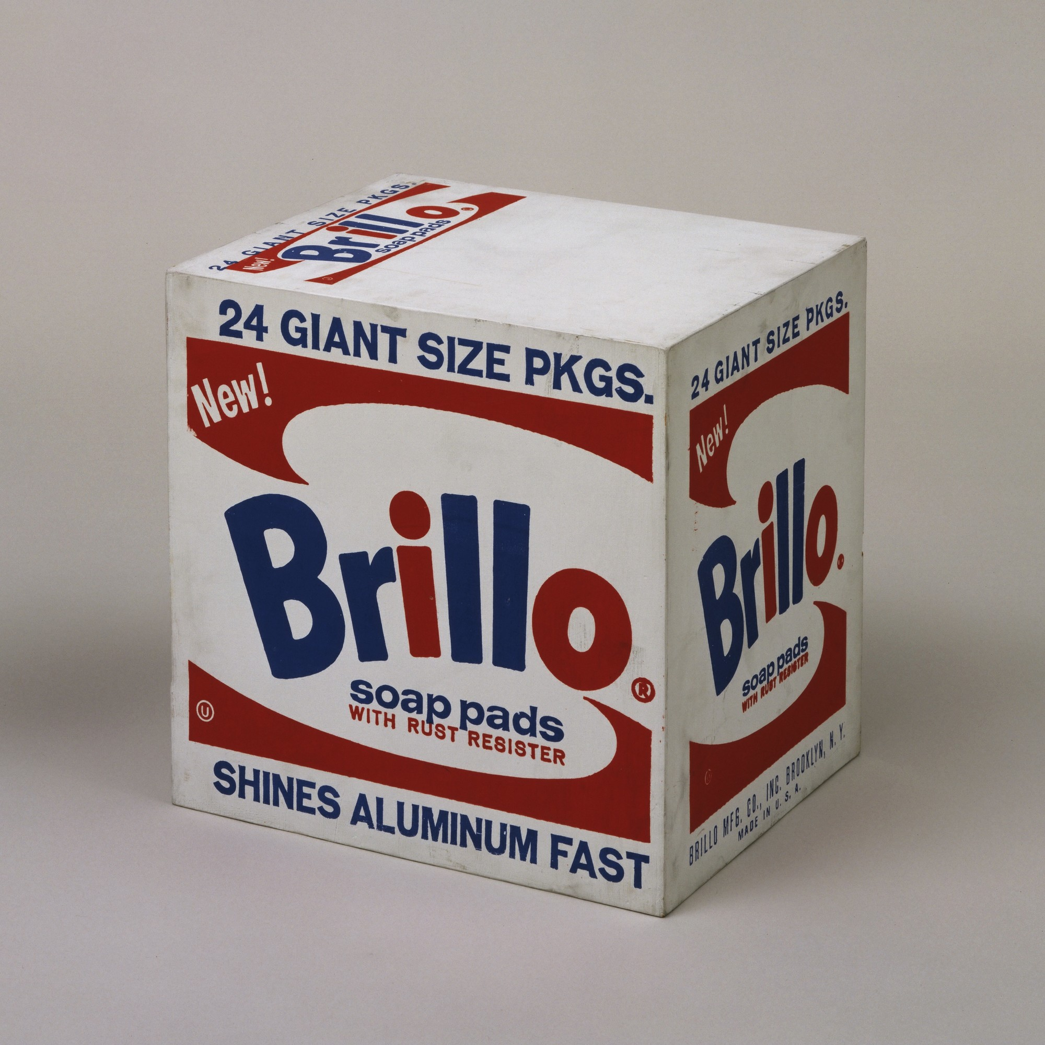

Figure 1. Warhol, A. (1946). *Brillo Box (Soap Pads)*. [readymade]. Retrieved from https://www.moma.org/collection/works/81384

Medium: Synthetic polymer paint and silkscreen ink on wood

Dimensions: 43.3 x 43.2 x 36.5 cm

Location: Museum of Modern Art, New York.

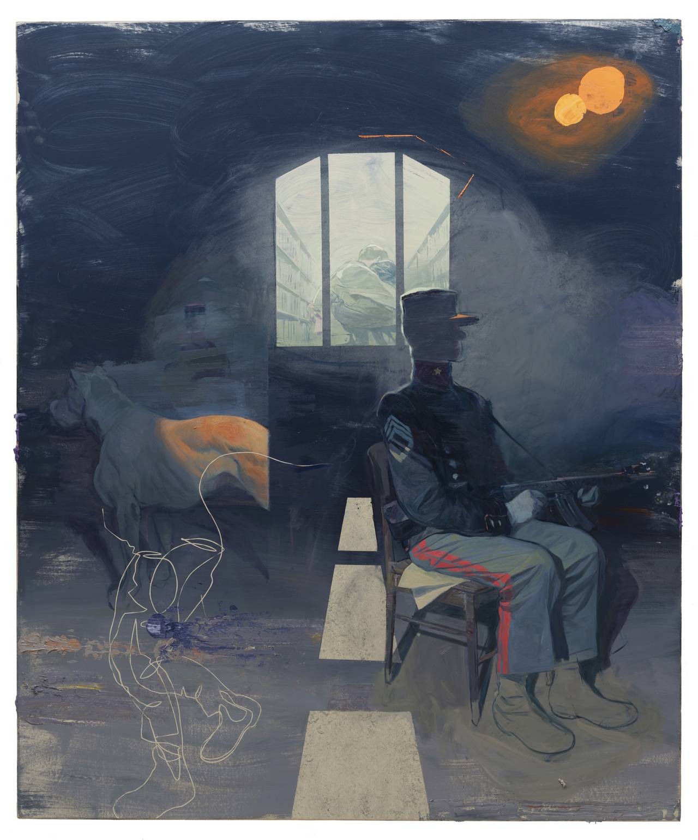

Figure 2. von Kaufmann, R. (2019). *No Man’s Land.* [painting]. Retrieved from <https://www.rvonkaufmann.com/works/2019/>

Medium: Oil on linoleum on wood

Dimension: 155 x 183 cm

Location: Collection of the Artist

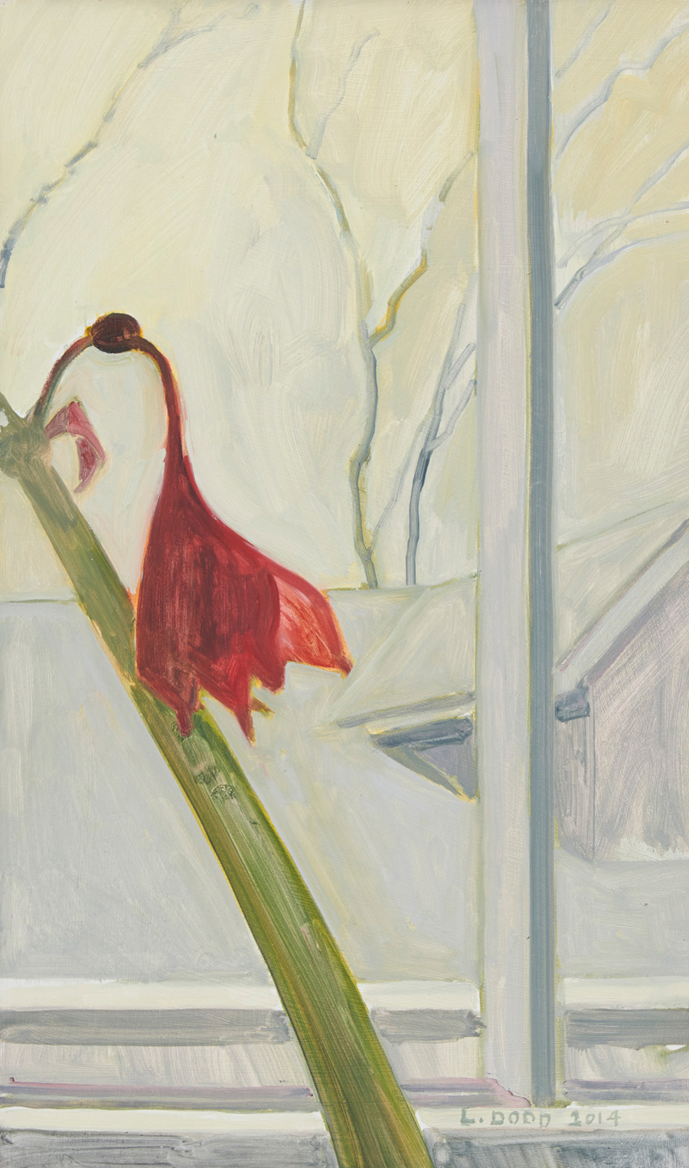

Figure 3. Dodd, L. (2014). *Fading Amaryllis.* [painting] Retrieved from https://www.frieze.com/article/lois-dodd-greatest-painter-windows-matisse

Material: oil on Masonite

Dimensions: 38 × 23 cm.

Location: Alexandre Gallery, New York

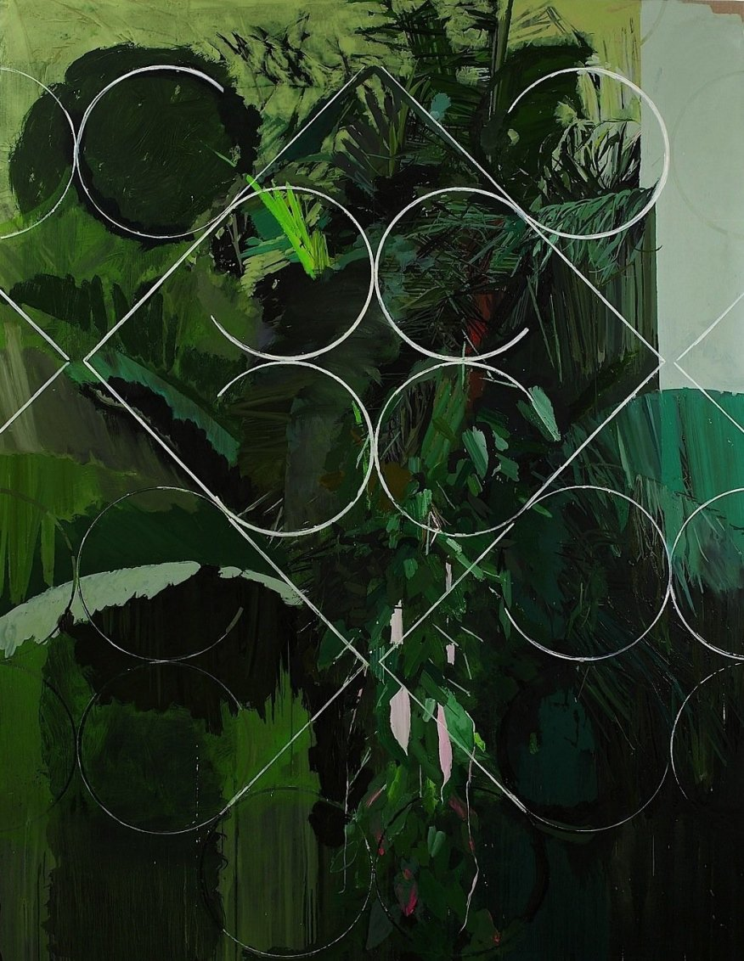

Figure 4. Anderson, H. (2010). *Constructed View.* [painting]. Retrieved from <https://www.thomasdanegallery.com/artists/28-Hurvin-Anderson/works/>

Medium: Oil on Canvas

Dimensions: Unknown

Location: Thomas Dane Gallery, London.

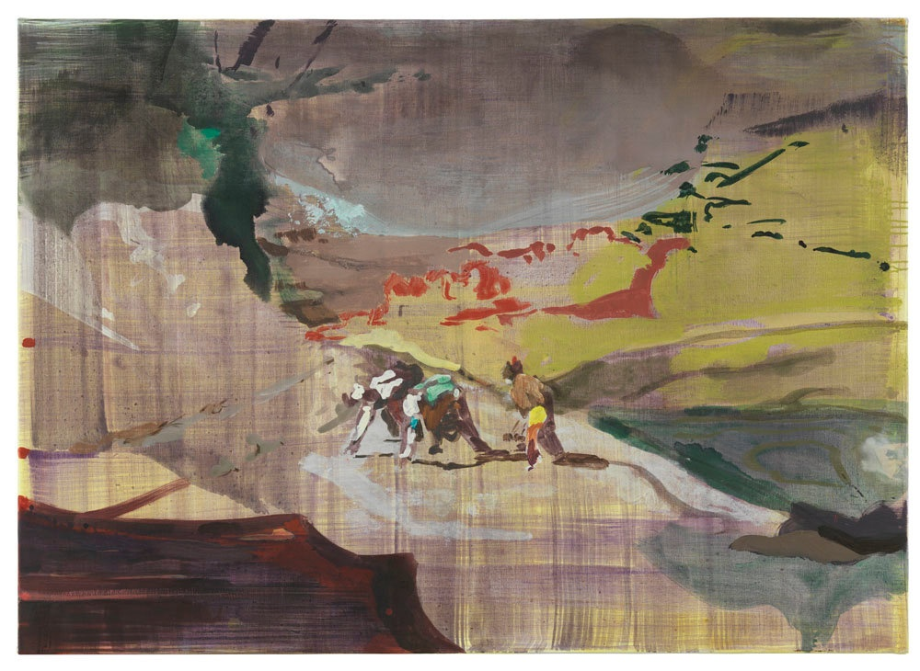

Figure 5. Na Kamura, M. (2014). *LD XXIII.* [painting]. Retrieved from <https://www.frieze.com/article/maki-na-kamura>

Medium: Oil and water on canvas

Dimensions: 100 × 140 cm

Location: DITTRICH & SCHLECHTRIEM, Berlin, Germany.

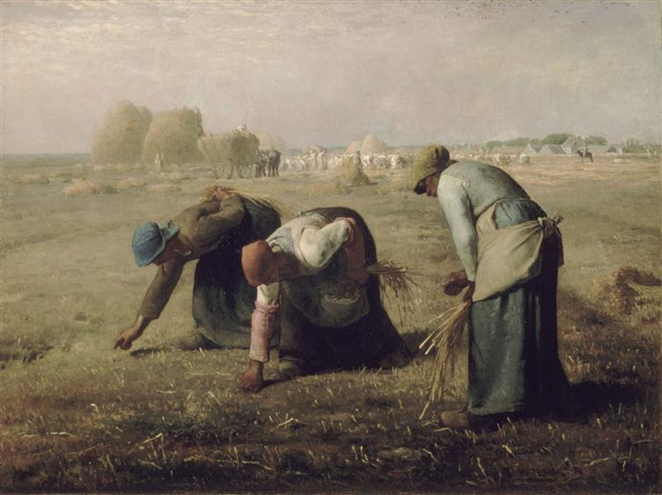

Figure 6. Millet, J. F. (1857). *The Gleaners.* [painting] Retrieved from <https://artsandculture.google.com/asset/gleaners/GgHsT2RumWxbtw?hl=en>

Medium: Oil on Canvas

Dimensions: 1100x830 cm

Location: Musée d'Orsay, Paris, Frace.

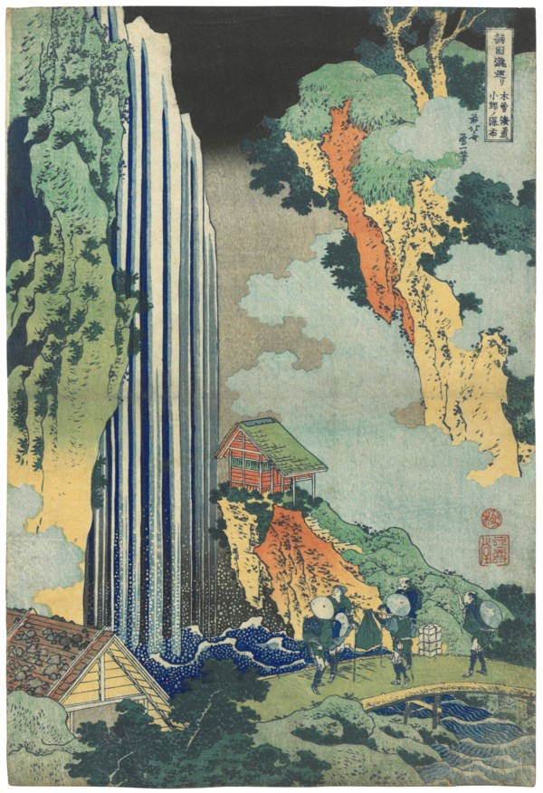

Figure 7. Hokusai, K. (1832). *The Waterfall at Ono on the Kisokaido Road.* [print]. Retrieved from https://www.metmuseum.org/art/collection/search/55020

Medium: Woodblock print; ink and color on paper

Dimensions: 37.8 x 26.2 cm

Location: Metropolitan Museum of Art, New York.

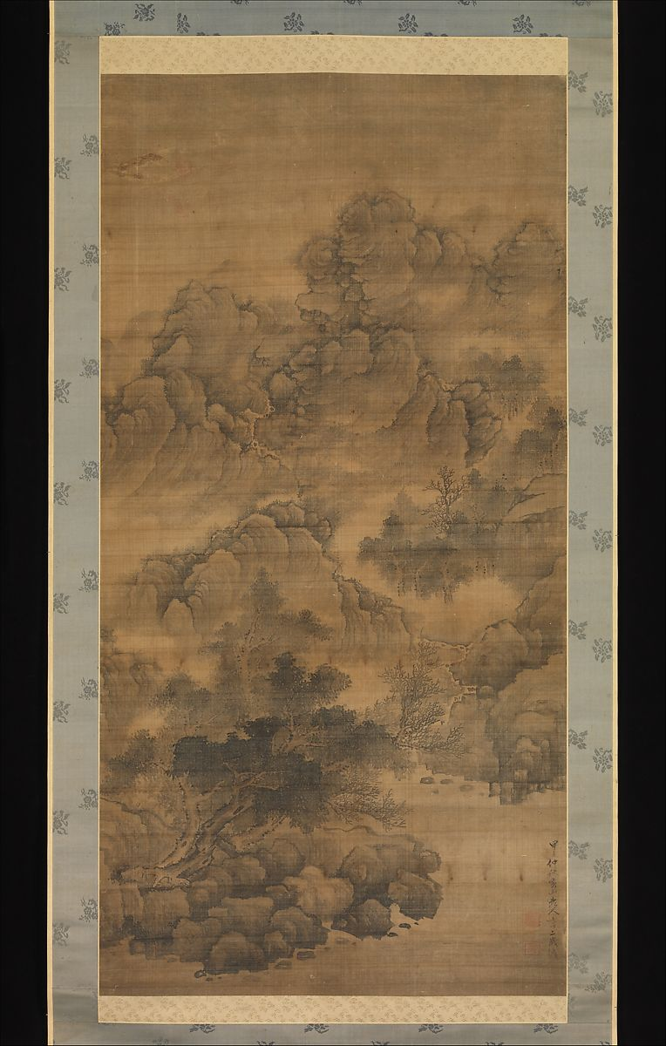

Figure 8. Ruozhen, F. (1684). *Cloudy Mountains.* [painting]. Retrieved from <https://www.metmuseum.org/art/collection/search/75745#:~:text=1684.%20Fa%20Ruozhen%20is%20known%20for%20his%20fantastical,this%20important%20scholar-artist%20of%20the%20early%20Qing%20dynasty>.

Medium: Hanging scroll, ink and color on silk

Dimensions: 137.5 x 69.5 cm

Location: Metropolitan Museum of Art, New York.

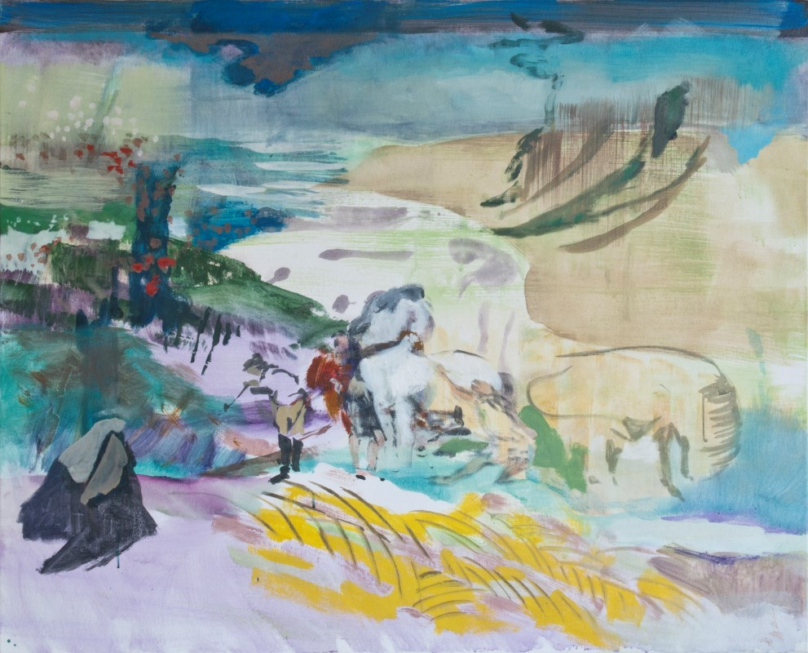

Figure 9. Na Kamura, M. (2010). *598. fGf XXX.* [painting]. Retrieved from <https://www.galerienoah.com/kuenstler/maki-na-kamura/>

Medium: Oil and water on canvas

Dimensions: 100x125 cm

Location: Galerie Noah, Augsberg, Germany

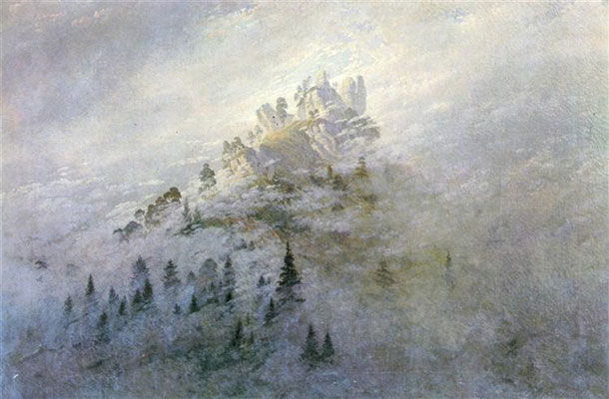

Figure 10. Friedrich, C. D. (1808). *Morning Mist in the Mountains*. [painting]. Retrieved from <https://www.theartstory.org/artist/friedrich-caspar-david/artworks/>

Medium: Oil on Canvas

Dimensions: 71 x 104 cm

Location: Gemäldegalerie, Berlin, Germany

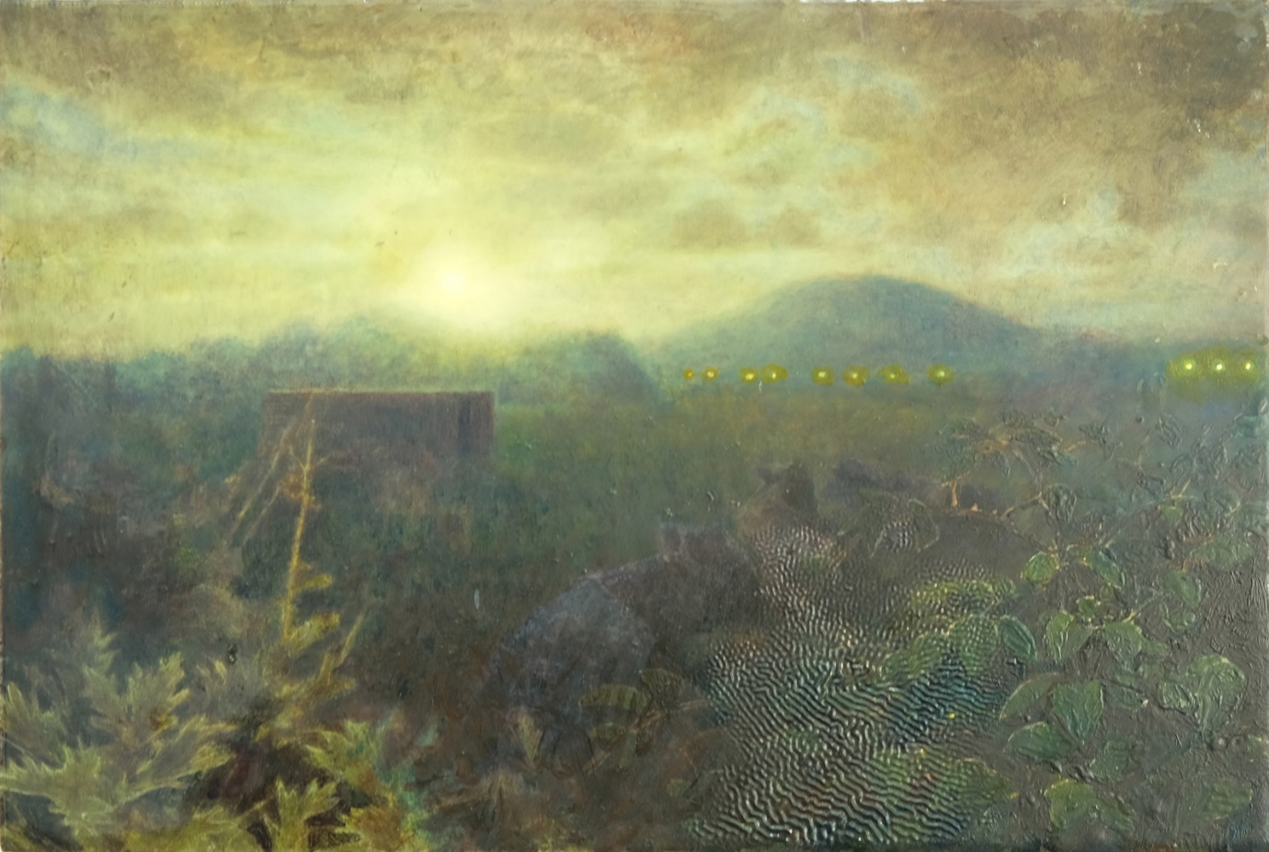

Figure 11. Douglas, S. (2015). *Sedgemoor.* [painting]. Retrieved from <https://charliesmithlondon.com/artists/sam-douglas/#&gid=1&pid=11>

Medium: Oil and varnish on Board

Dimensions: 16 x 24 cm

Location: Charlie Smith, London, UK

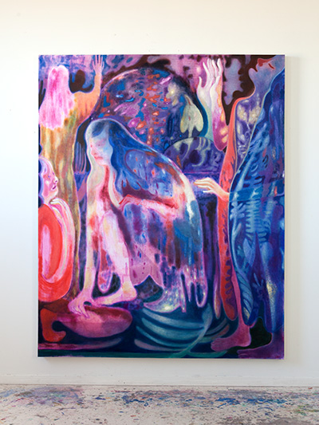

Figure 12. Ruznic, M. (2018). *Light Summoners.* [painting]. Retrieved from <http://artsandculturetx.com/texas-studio-maja-ruznic/>

Medium: Oil on Canvas

Dimensions: 195 x 160 cm

Location: Collection of the Artist.

**APPENDIX**

This research has provided me with great insight into how to develop my own painting practice. I have become increasingly conscious of and inquisitive regarding my employment of polarity and oscillation within my paintings. I aim to create works that straddle the precipice between abstraction and figuration.

In my paintings, I set out to create depictions of other-worldly spaces within which oscillation would occur. The noticeable revival of Romantic principles in contemporary Painting reassures me that my simple intentions are relevant to the painting world’s broader happenings. I now intend, however, to lean into the ineffable more than ever. I feel comfortable with the idea that I can paint under the guidance of my mind’s eye only; if a vision of a painting generates within my mind and it inexplicably compels me to paint it, I will. Too often in the past, I have let an idea escape me because I cannot comprehend it rationally or conceptually explain it with words. This thinking has generated a desire within me to explore the aesthetic experience as a communicative tool.

In its many approaches, Painting seems to be a form of language that is unfortunately not as well understood as written or spoken word due to its very nature. I believe, however, that paintings can communicate deep meanings understood outside the rational mind and beyond the interpretability of spoken language. Through diligent practice, I intend to comprehend somewhat the communicative power of beauty and the aesthetic experience. I am realising that there is an ineffable yet formidable presence in Painting that cannot be comprehended with rationality, logic, or words. The only way for one to comprehend the ineffable magic of Painting, it seems, is through Painting.